Assignmnet no. 5

1) Write a query that will give you all orders for more than Rs. 1,000.

Ans -
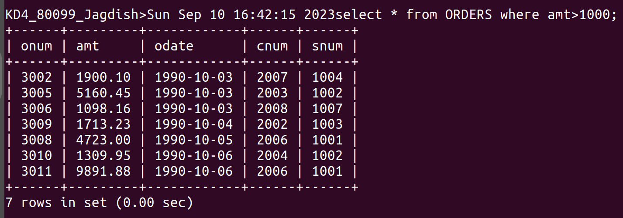
2) Write a query that will give you the names and the cities all salespeople in London with a commission above .10

Ans-

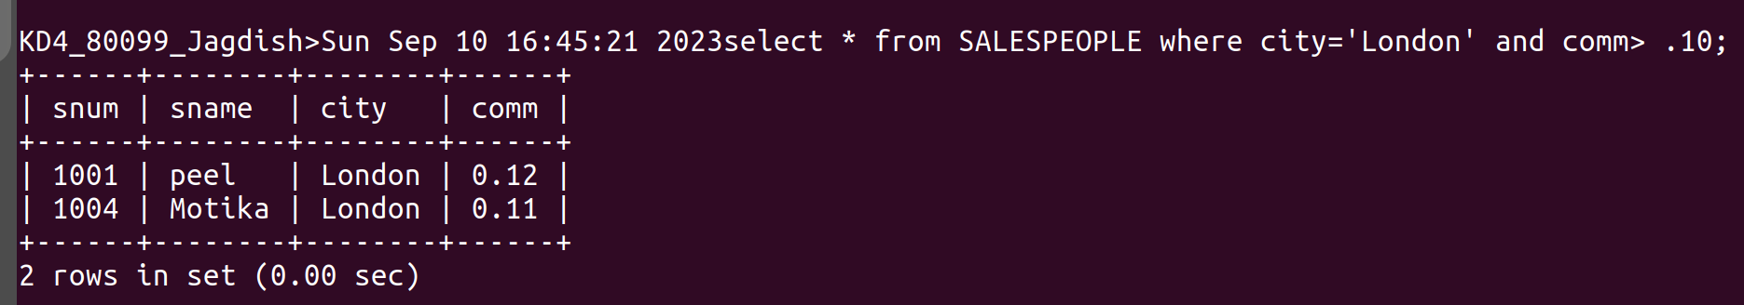
3) Write a query on the customers table whose output will exclude all customers with a rating <=100, unless they are located in Rome.

Ans-

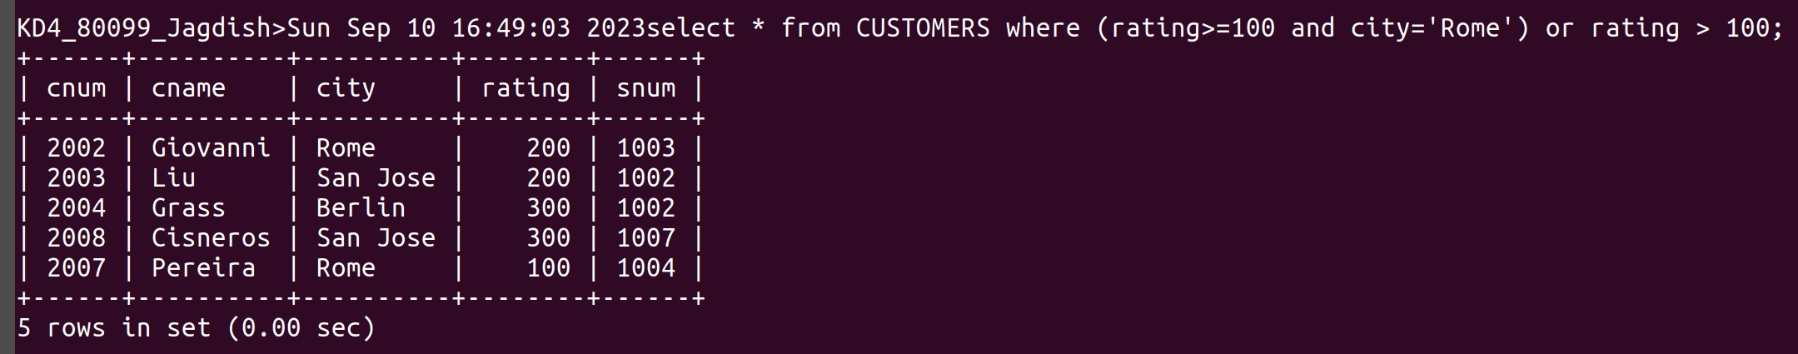
4)What will be the ouyput from the following query?

Select * from orders where (amt < 1000 or not (odate =’1990-10-03’ and cnum>2003));

Ans-
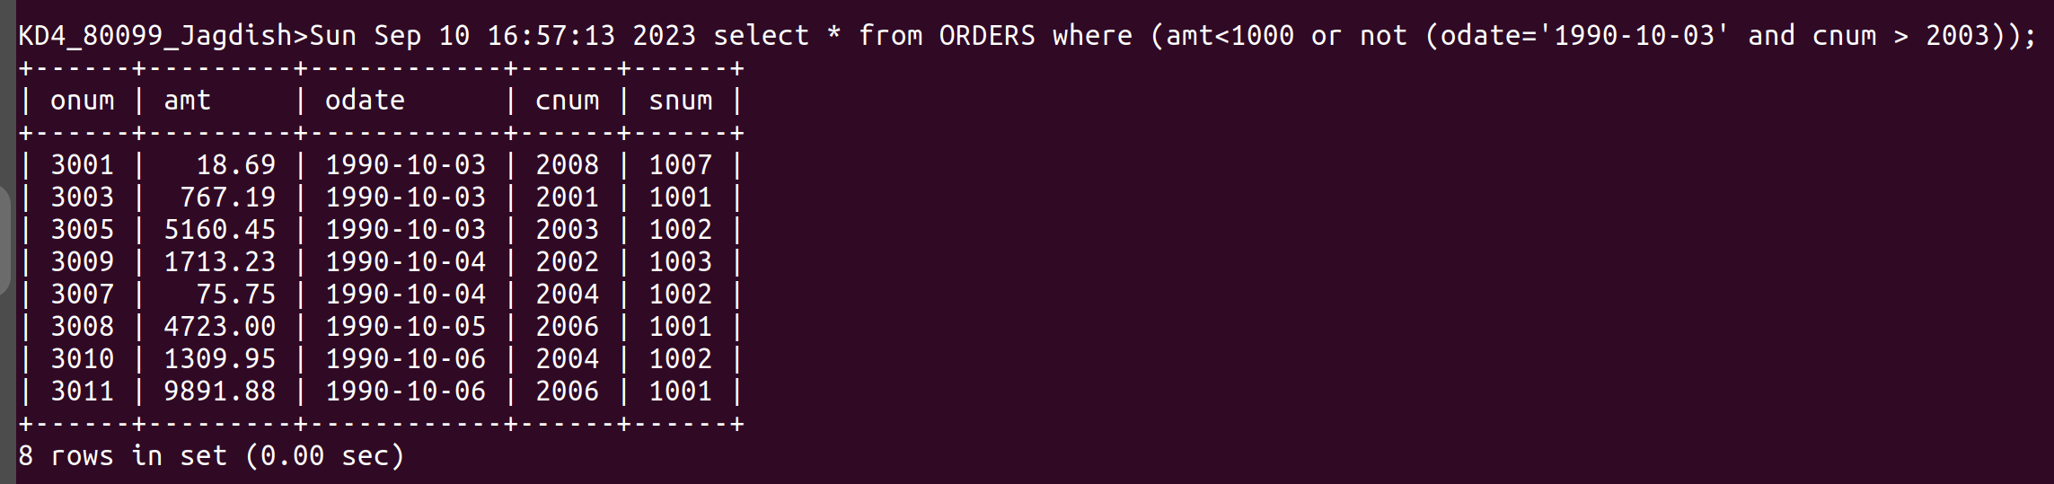
5) what will be the output of the following query?

Select * from orders where not ((odate = ‘1990-10-03’ or snum>1006) and amt>=1500);
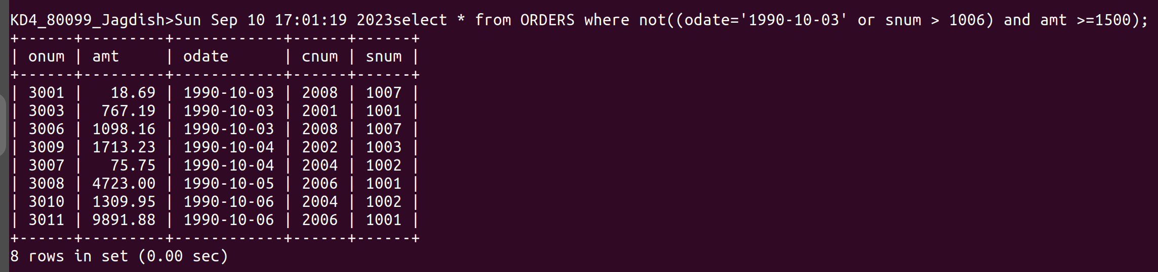
Ans -
6) what is the simplest way to write this query ? Select snum,sname,city,comm from the salespeople where (comm >.12 or comm <.14);

Ans-
